การตั้งค่าของ Kerlin iStation

<https://wikikerlink.fr/wirnet-productline/doku.php?id=wiki:quickstart:quickstart_istation>

5. Packet Forwarder activation and configuration

Kerlink provides a packet forwarder (CPF) compatible

5.1 Packet forwarder activation

Default = Enable

* 1. Packet Forwarder configuration

1.How to configure and monitor the packet forwarder?

The configuration is achieved in 3 steps:

* lorad configuration
* lorafwd configuration
* monitoring and auto-start configuration
  1. lorad configuration

เป็นการกำหนด frequency plan ของแต่ละประเทศ ซึ่งจะมี Template ของ frequency plan อยู่ใน Folder /etc/lorad/PLATFORM PLATFORM จะมีค่าดังนี้ ibts, wifc, wiis or fevo

Copy ตาม PLATFORM ไปไว้ที่ /etc/lorad/lorad.json file. ด้วยชื่อ lorad.json

1. /etc/lorad/ wiis/AS923-TH-SG-HK-TW.json to /etc/lorad/lorad.json

The goal of the lorad configuration is to define the frequency plan that will be used to receive packets from the end-devices, to enable the LBT feature and to configure the class B beacons.

A few frequency plan templates are pre-installed on the gateway (under /etc/lorad/PLATFORM where PLATFORM equal to ibts, wifc, wiis or fevo): it is strongly recommended to copy the expected frequency plan templates in /etc/lorad/lorad.json file. The goal is to keep templates unmodified.

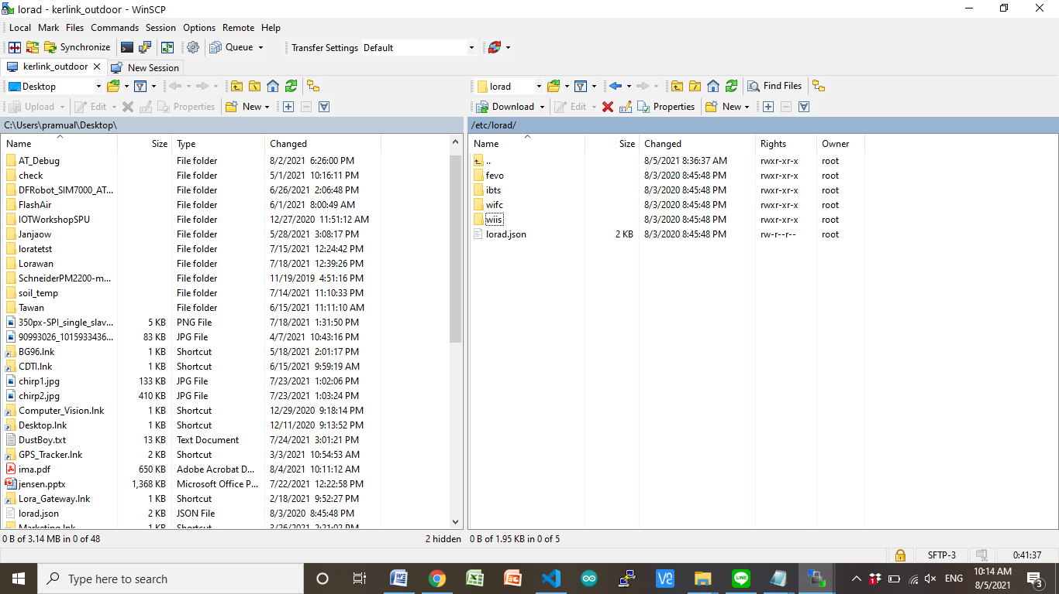

1. แก้ไข file lorad /etc/default/

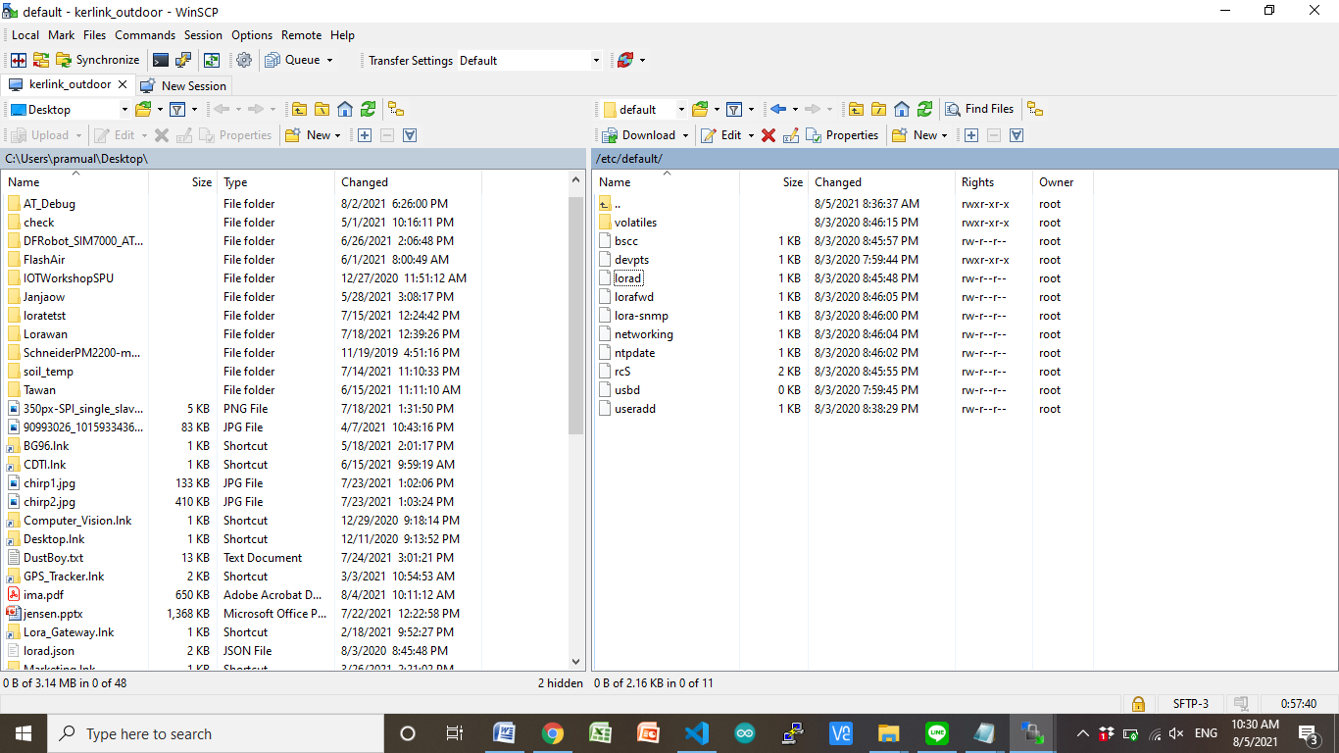

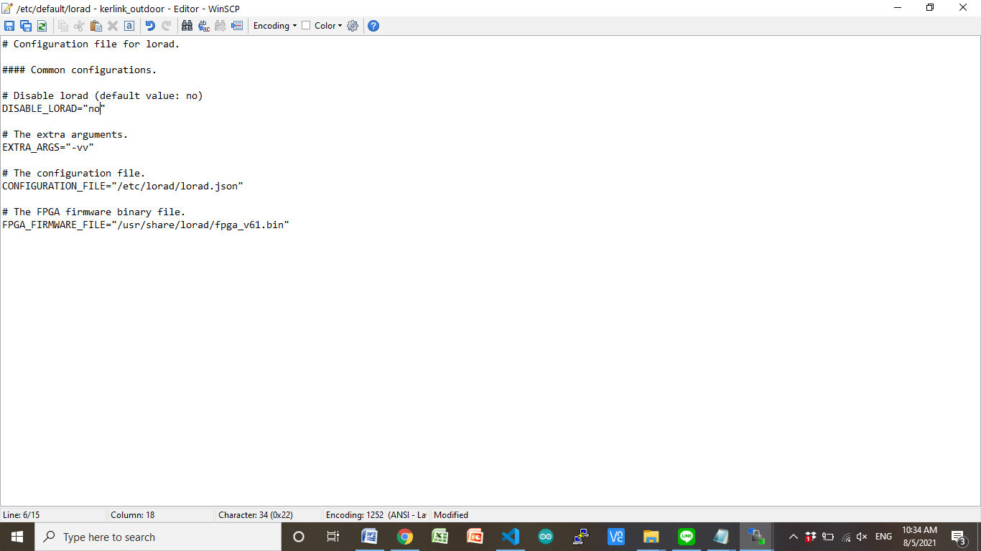

Edit /etc/default/lorad and make sure that the CONFIGURATION_FILE field links to the template you previously copied.

Edit /etc/default/lorad and make sure that DISABLE_LORAD=“no” is present in this file. If lorad is disabled consult the following page to activate the CPF: Keros application configuration - click here.

Edit the template you copied to adapt it to your needs. Since the hardware between gateways is different, the configuration on each gateway differs (although it is quite similar).

Wirnet iBTS

Wirnet iFemtoCell, iFemtoCell-evolution and Wirnet iStation

1.2 lorafwd configuration

The goal of the lorafwd configuration is mainly to define to which LNS LoRa packets will be forwarded to.

1. แก้ไข file lorafwd /etc/default/

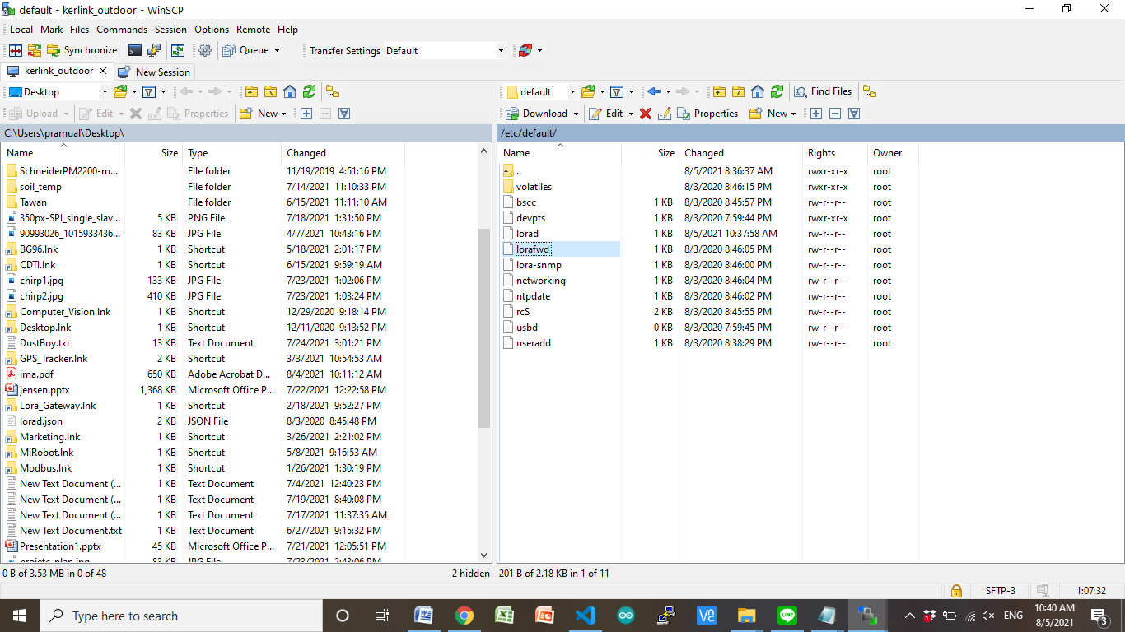

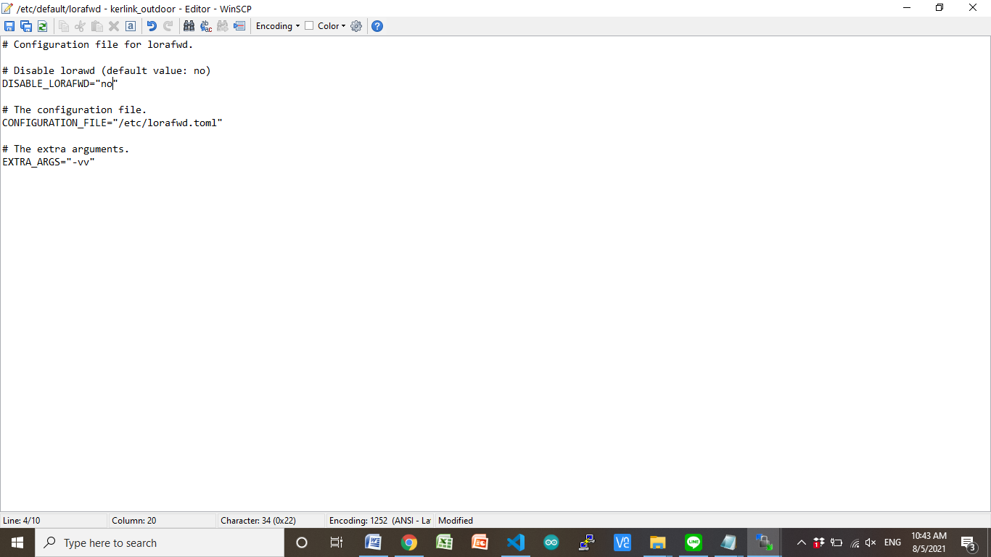

Edit /etc/default/lorafwd and make sure that DISABLE_LORAFWD=“no” is present in this file. If lorafwd is disabled consult the following page to activate the CPF: Keros application configuration - click here.

Edit /etc/lorafwd.toml. This configuration file is formatted using the TOML v0.5.0 language:

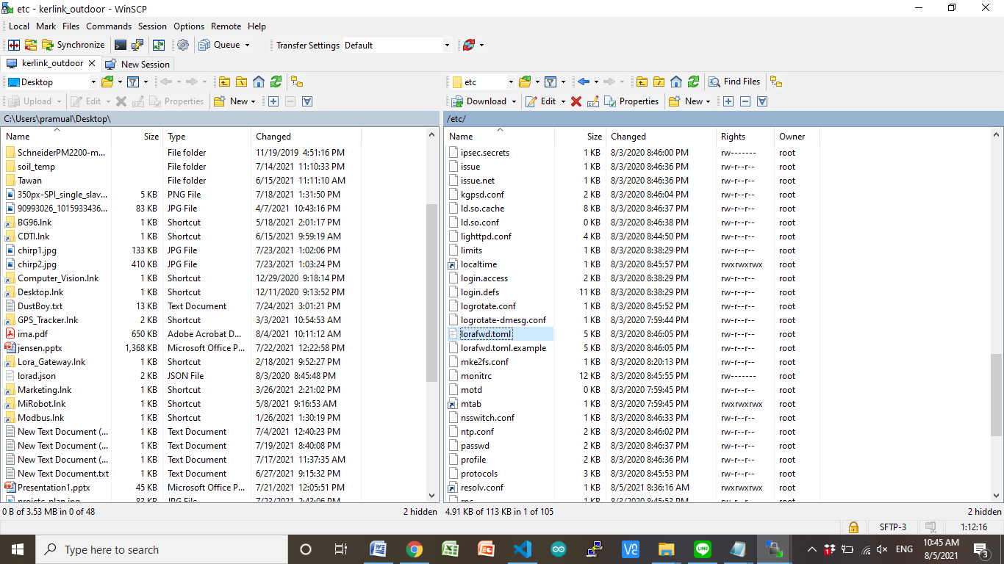

ค้นหา gwmp

gwmp.node = "127.0.0.1": The address of the LNS.

gwmp.service.uplink = 1700: The uplink port of the LNS.

gwmp.service.downlink = 1700 : The downlink port of the LNS.

Most keys are pre-configured with correct values.

The description of each key is directly written in the configuration file. If this configuration file has been modified, use /etc/lorafwd.toml.example as a model

Hereunder are the keys that must be changed to chose your LNS:

gwmp.node = “localhost”: The address of the LNS.

gwmp.service.uplink = 20000: The uplink port of the LNS.

gwmp.service.downlink = 20000 : The downlink port of the LNS.

1.3 Monitoring and auto-start configuration

By default, both lorad and lorafwd are started at boot time. If for some reason, one of the daemons stops, it will be automatically restarted by monit.

คำสั่ง

$>monit status

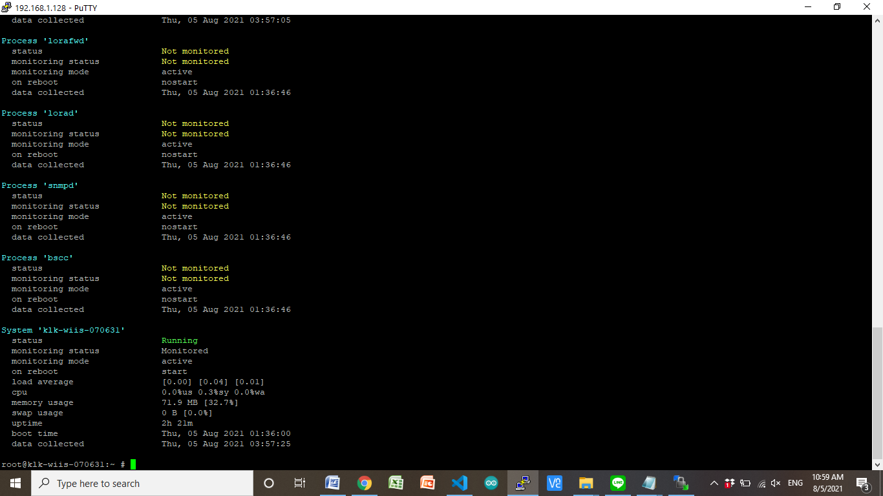

$>monit stop lorad

$>monit start lorad

$>monit stop lorafwd

$>monit start lorafwd

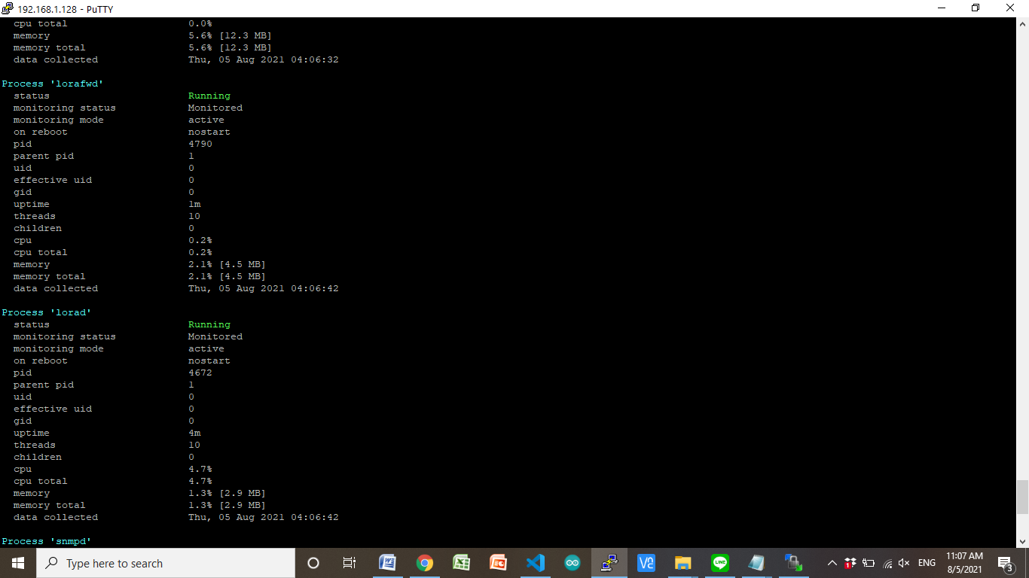

The autostart behavior is handled by the symlinks /etc/rcU.d/S50lorad and /etc/rcU.d/S51lorafwd.

The monitoring behavior is handled by the /etc/monit.d/lorad and /etc/monit.d/lorafwd files.

The daemons can be started/stopped/rebooted and monitored with monit. See monit page for more details.

Both daemons are independent. If one is stopped/restarted, the other one does not need to be stopped/restarted.

Log managment

Both daemons generates logs in the /var/log/lora.log* files.

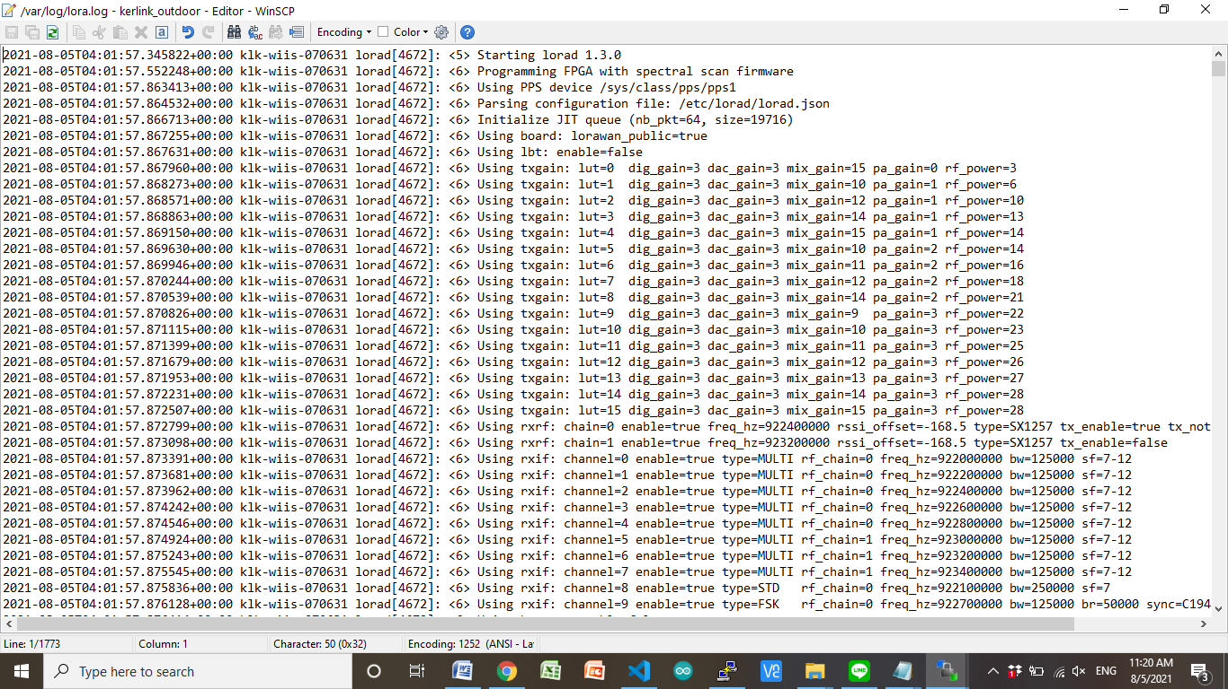

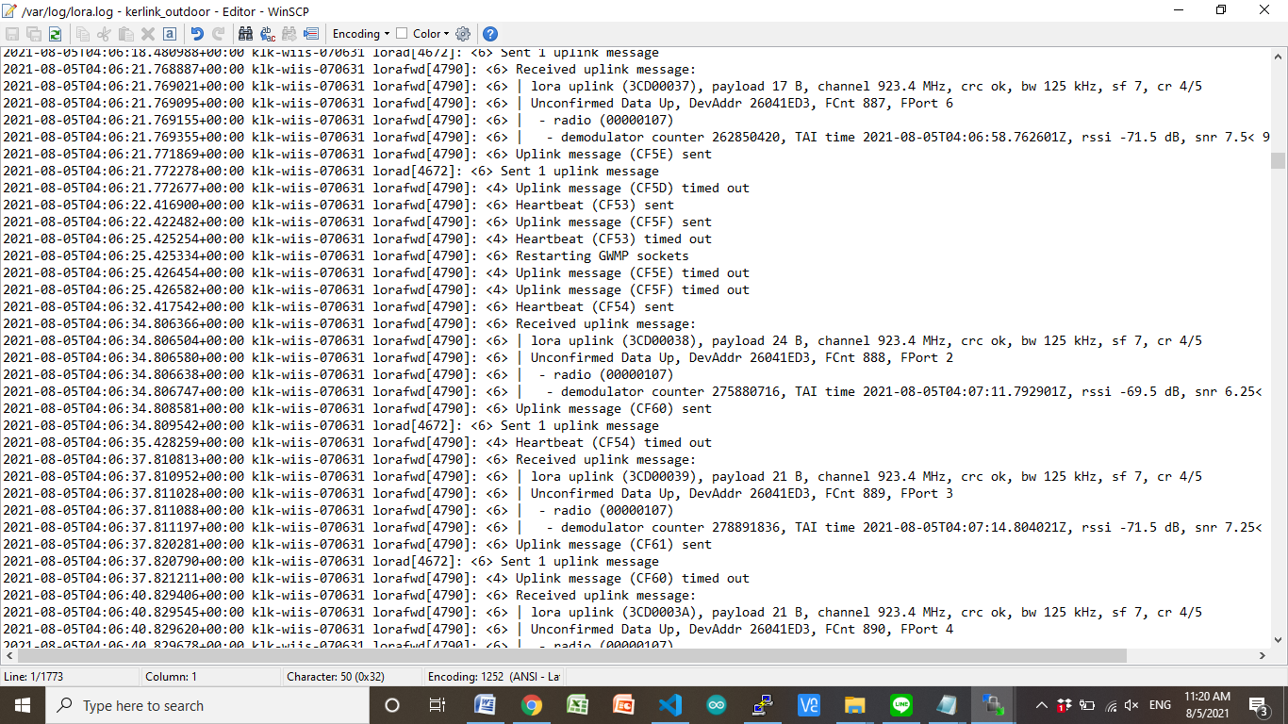

The verbosity of the daemons can be increased using the EXTRA_ARGS field under /etc/default/lorad and /etc/default/lorafwd.

lorad:

NOTICE = -v: Displays start and stop traces

INFO = -vv:

Displays the configuration of the hardware (frequencies, bandwidth, spreading factor, antenna, LBT, …)

Displays the number of uplinks and beacons sent.

Displays TAI/PPS info

…

DEBUG = -vvv: Displays the hexdump of the packets

lorafwd:

NOTICE = -v: Displays start and stop traces

INFO = -vv:

Displays the configuration of the forwarder (gateway ID, LNS, uplink/downlink port, GWMP configuration, …)

Displays the uplinks and downlink meta-data

Displays the acknowledge / heartbeat / drop traces

…

DEBUG = -vvv: Displays the hexdump of the packets

gateway EUI

Gateway EUI is used by LNS to identify from which gateway messages come from.

When lorafwd starts, a file containing the default EUI is generated, based on information included in /tmp/board_info.json.

cat /var/run/lora/gateway-id.toml

gateway.id = 0x7076FF0039050789 Indoor

gateway.id = 0x7076FF0054070631 Outdoor

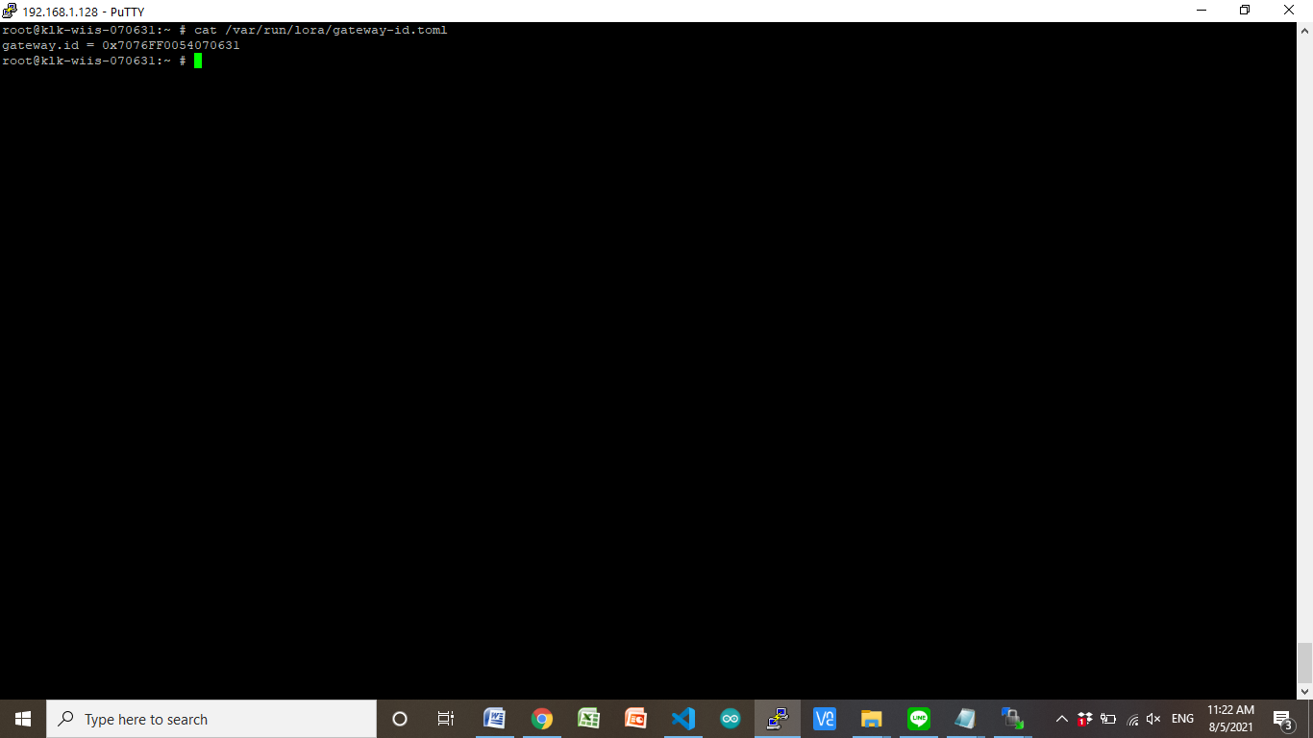

If a new EUI has been defined under /etc/lorafwd.toml, then, this new EUI is used by lorafwd. Otherwise, the default EUI is used.

การตั้งค่า Kerlink Gateway สำหรับ chirpstack (Network Server)

1. SSH เข้าไปที่ Kerlink gateway
2. Enable Kerlink CPF default = disable

$>klk_apps_config --activate-cpf

1. Configure Kerlink CPF

แก้ไข file /etc/lorafwd/lorafwd.toml ในส่วนของ gwmp

node = "127.0.0.1"

service.uplink = 1700

service.downlink = 1700

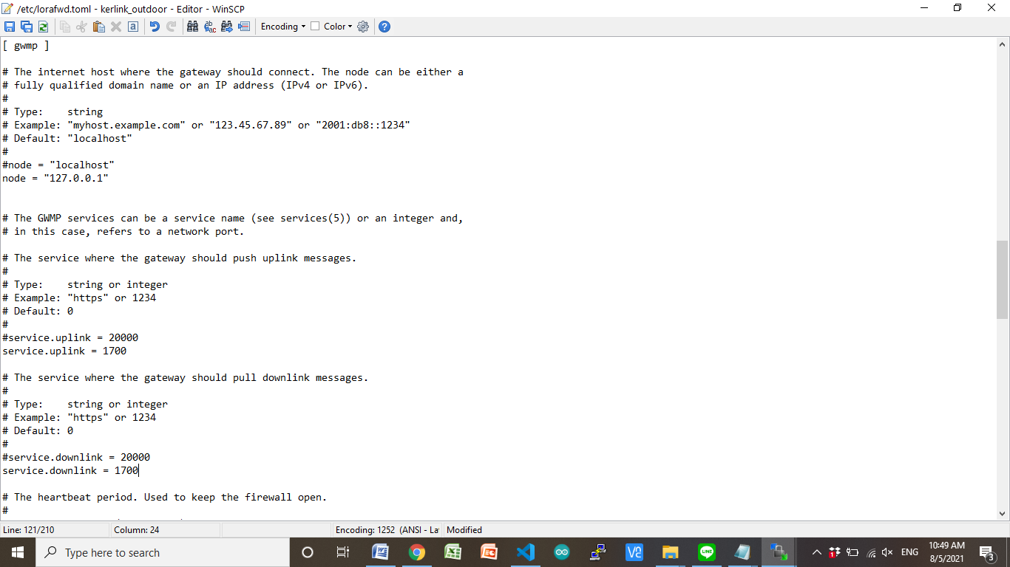

หลังจากทำการแก้ไข file /etc/lorafwd/lorafwd.toml จะต้องทำการ restart lorafwd service

$>monit restart lorafwd

1. ทำการติดตั้ง Install ChirpStack Gateway Bridge

$> cd /user/.updates

$>wget <https://artifacts.chirpstack.io/vendor/kerlink/keros-gws/chirpstack-gateway-bridge_3.12.0-r1_klkgw.ipk>

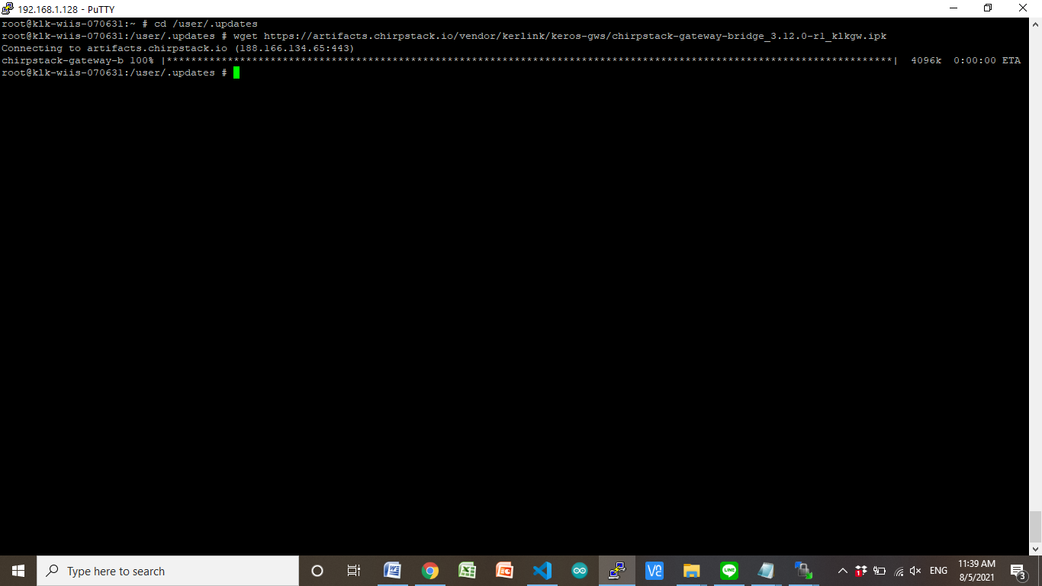

ทำการ To trigger the gateway to install / update the package, run the following commands:

$>sync

$>kerosd -u

$>reboot

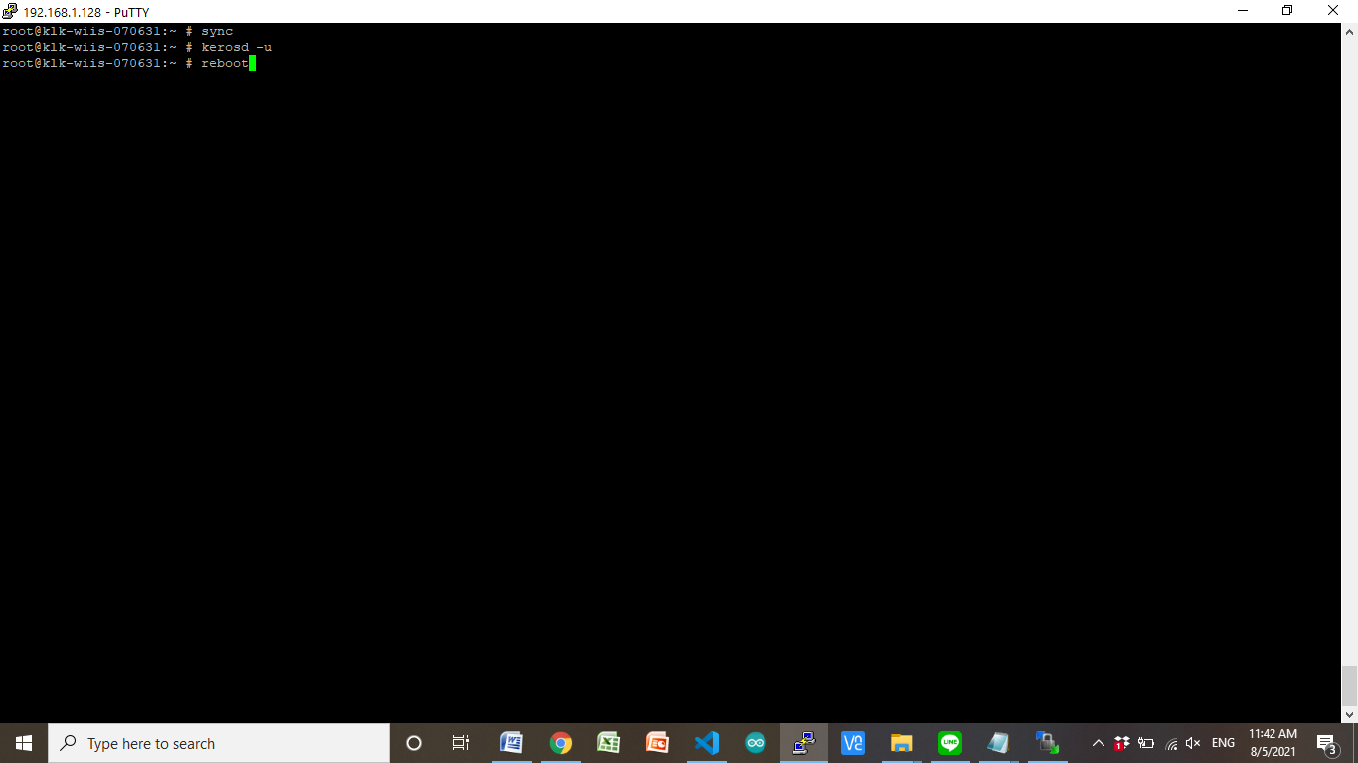

ทำการตั้งค่า Configure ChirpStack Gateway Bridge

การต่อ ChirpStack Gateway Bridge เข้ากับ MQTT broker จะต้อง update file

/etc/chirpstack-gateway-bridge/chirpstack-gateway-bridge.toml.

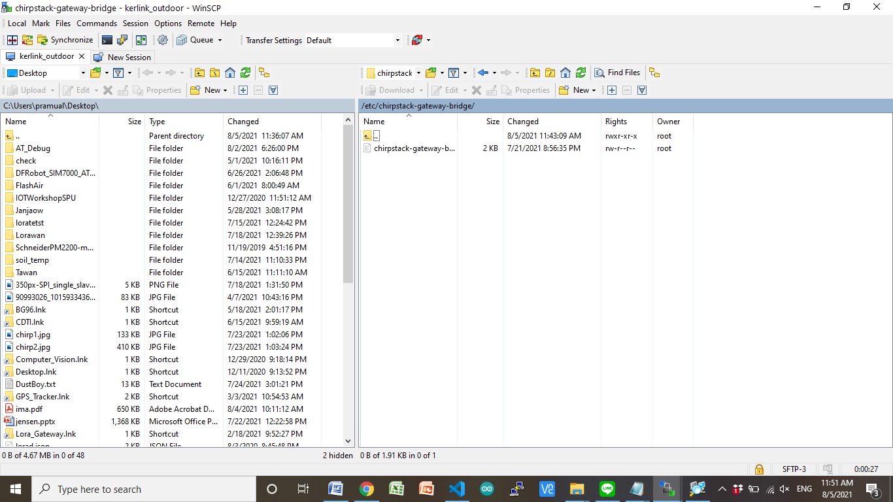

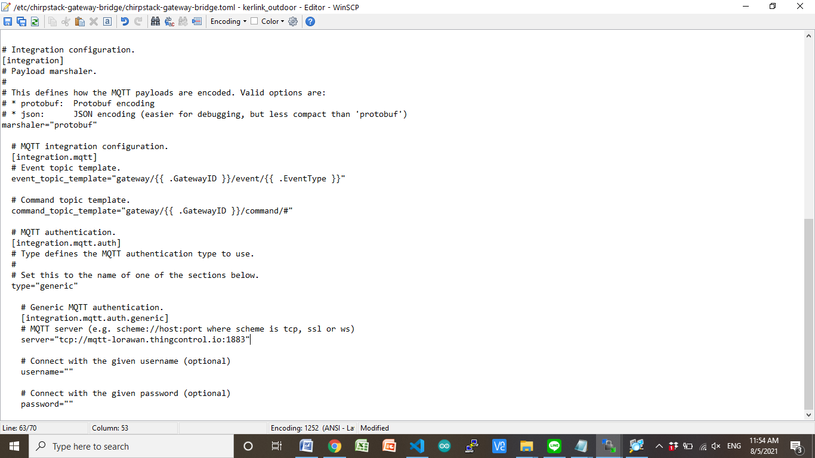

# Generic MQTT authentication.

server="tcp://mqtt-lorawan.thingcontrol.io:1883"

คำสั่งสำหรับ ChirpStack Gateway Bridge Service

(Re)start and stop commands

# status

monit status chirpstack-gateway-bridge

# start

monit start chirpstack-gateway-bridge

# stop

monit stop chirpstack-gateway-bridge

# restart

monit restart chirpstack-gateway-bridge

From chirpstack web site

https://www.chirpstack.io/gateway-bridge/gateway/kerlink/

Kerlink iFemtoCell

Product detail page

Note: These steps have been tested using the KerOS firmware v4.1.6. Please make sure you have this version or later installed. You must also install the Kerlink Common Packet Forwarder.

SSH into the gateway

The first step is to login into the gateway using ssh:

ssh root@GATEWAY-IP-ADDRESS

Please refer to the Kerlink wiki for login instructions.

Install IPK package

Find the latest package at https://artifacts.chirpstack.io/vendor/kerlink/ifemtocell/ and copy the URL to your clipboard. Then on the gateway use wget to download the package into a folder named /user/.updates. Example for chirpstack-gateway-bridge_3.10.0-r1_klkgw.ipk:

mkdir -p /user/.updates

cd /user/.updates

wget https://artifacts.chirpstack.io/vendor/kerlink/ifemtocell/chirpstack-gateway-bridge_3.10.0-r1_klkgw.ipk

To trigger the iFemtoCell gateway to install / update the package, run the following commands:

sync

kerosd -u

reboot

Please refer to the Kerlink wiki for more information about installing and updating packages.

Edit the ChirpStack Gateway Bridge configuration

To connect the ChirpStack Gateway Bridge with your MQTT broker, you must update the ChirpStack Gateway Bridge configuration file, which is located at: /user/etc/chirpstack-gateway-bridge/chirpstack-gateway-bridge.toml.

(Re)start and stop commands

Use the following commands to (re)start and stop the ChirpStack Gateway Bridge Service:

# status

monit status chirpstack-gateway-bridge

# start

monit start chirpstack-gateway-bridge

# stop

monit stop chirpstack-gateway-bridge

# restart

monit restart chirpstack-gateway-bridge

Configure packet-forwarder

You must configure the packet-forwarder on the gateway to forward its data to 127.0.0.1 at port 1700. The file /user/etc/lorafwd/lorafwd.toml must contain the following lines under the [ gwmp ] section:

node = "127.0.0.1"

service.uplink = 1700

service.downlink = 1700

After updating this configuration file, make sure to restart the lorafwd service:

monit restart lorafwd

/var/run/lora/gateway-id.toml